Week – 2
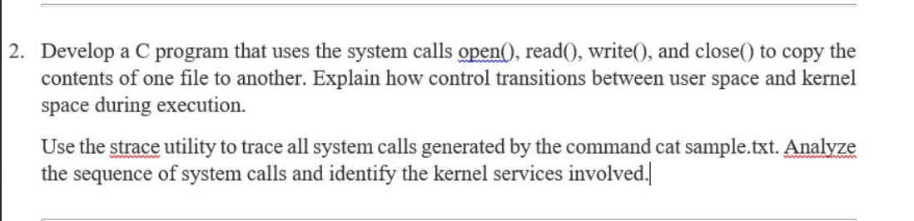

Code:-
#include<stdio.h>
#include<unistd.h>
#include<fcntl.h>
#include<stdlib.h>
int main(){
int fd1, fd2, n;
char buf[100];
char src[50], dest[50];
printf("Enter source file name:\n");
scanf("%s", src);
fd1 = open(src, O_RDONLY);
if(fd1 < 0){
printf("Error opening source file\n");
exit(1);
}
printf("Enter destination file name:\n");
scanf("%s", dest);
fd2 = open(dest, O_WRONLY | O_CREAT | O_TRUNC, 0644);
if(fd2 < 0){
printf("Error creating destination file\n");
close(fd1);
exit(1);
}
while((n = read(fd1, buf, 100)) > 0){
write(fd2, buf, n);
}
close(fd1);
close(fd2);
printf("File copied successfully\n");
return 0;
}

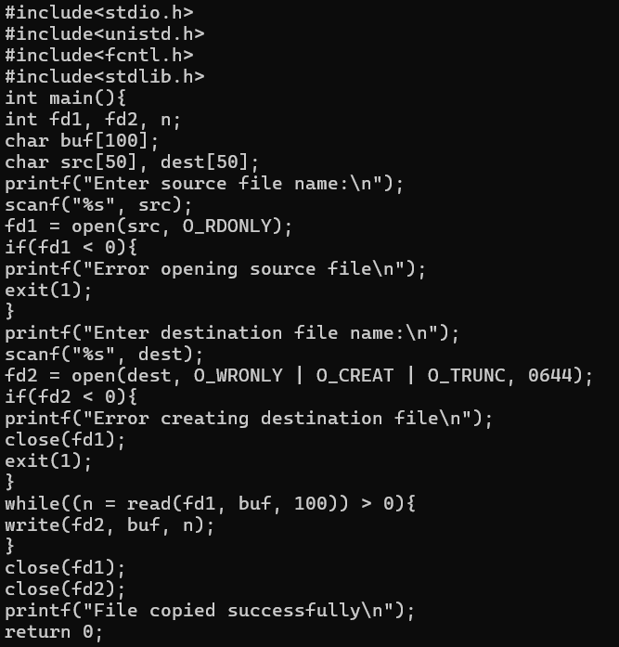

Output:-


